**Name :- Shantanu Rana**

**SAP ID :- 500082398**

**LAB EXERCISE 4**

**Aim: Install and Manage Maven Plugin using Eclipse**

Install Site Plugin and use “mvn site” command and goal for generating documents for Maven Project using Eclipse.

**Step 1 :- First create a Maven project and provide Group id, Artifact id and Name.**

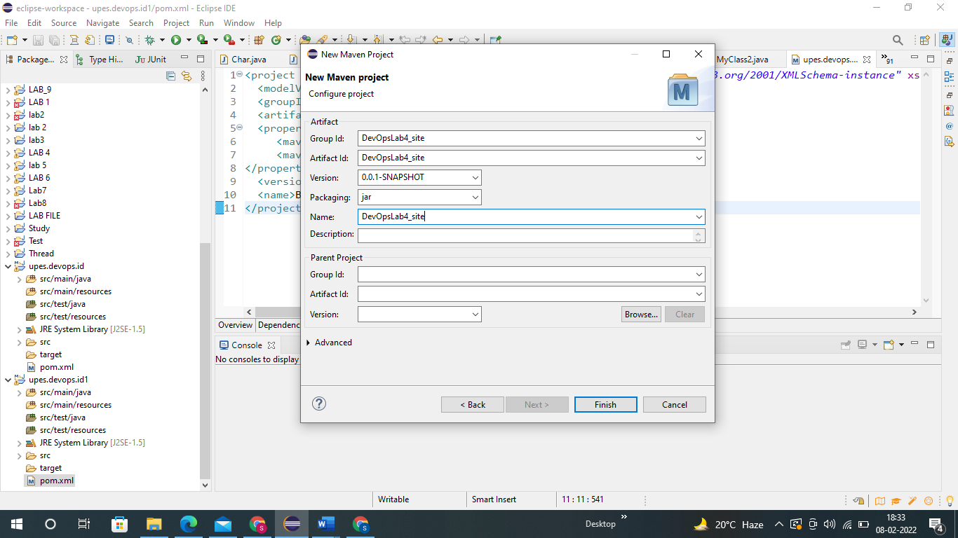

**Step 2 :- Now create a package inside it.**

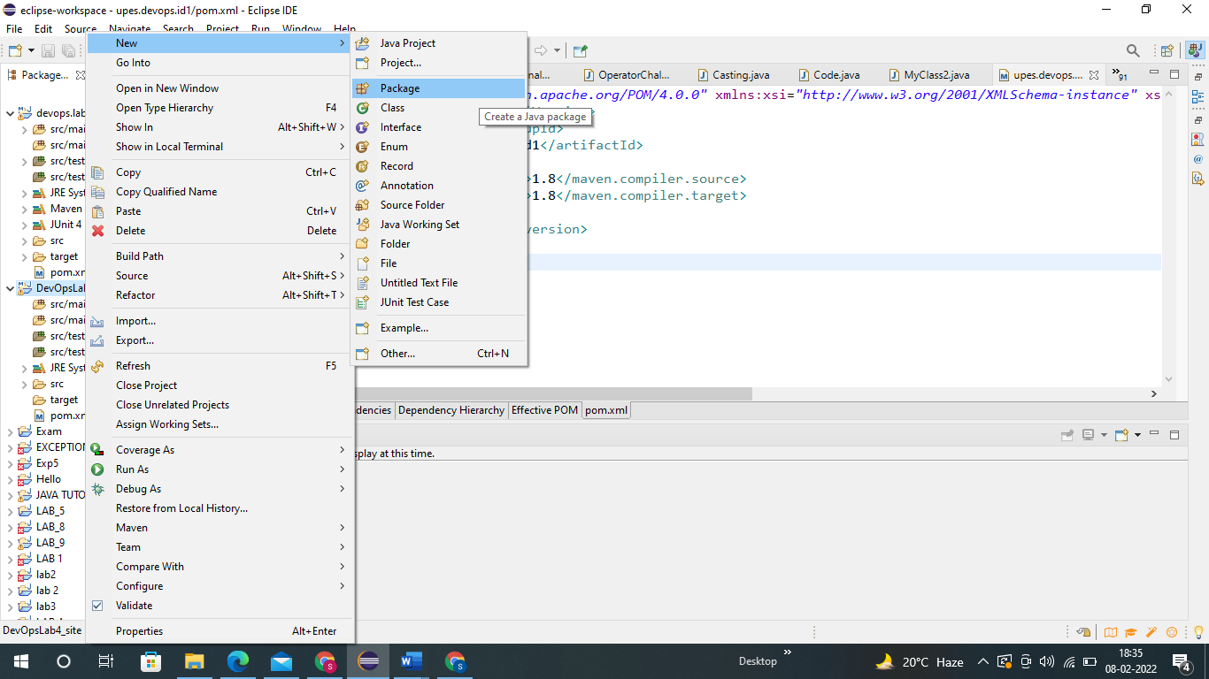

**Step 3 :- Now In that package create a class.**

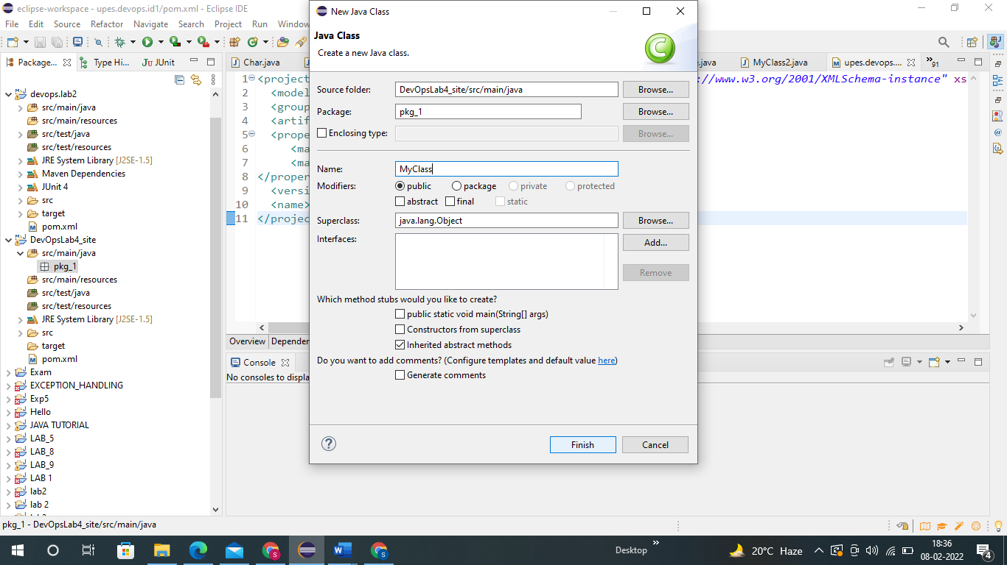

**Step 4 :- Now create a method of Average in it.**

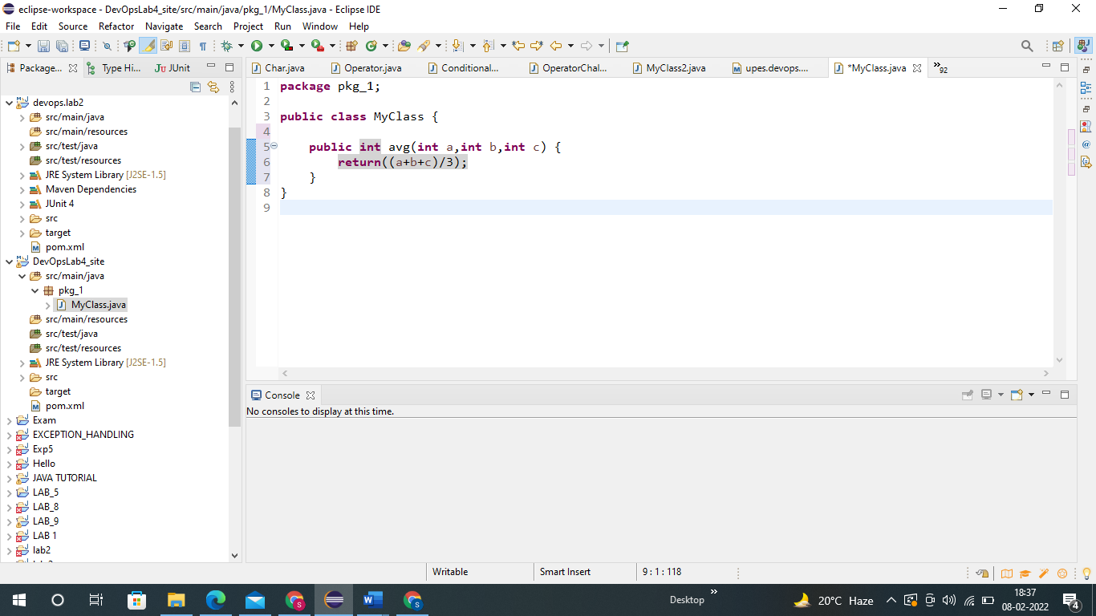

**Code :-**

**package** pkg_1;

**public** **class** MyClass {

**public** **int** avg(**int** a,**int** b,**int** c) {

**return**((a+b+c)/3);

}

}

**Step5:- Now create a new class under package and call the class having code by creating object of it.**

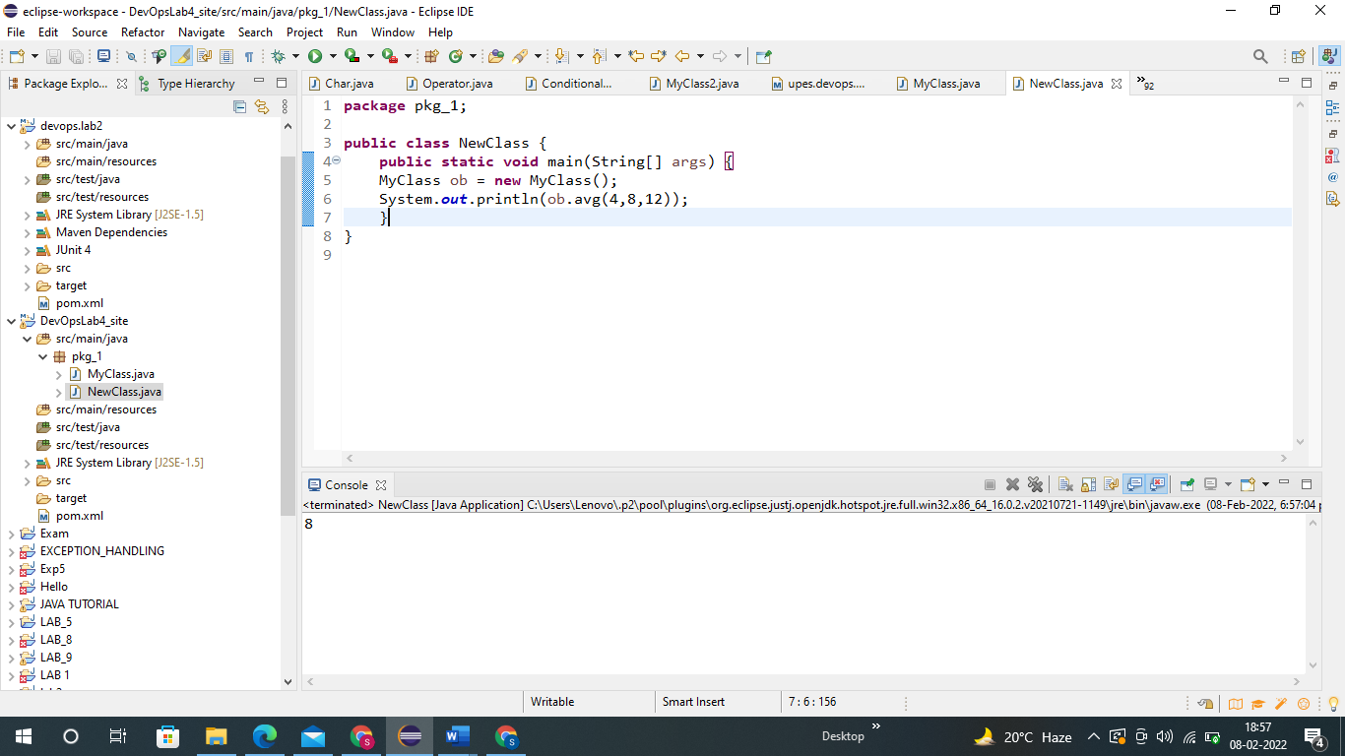

**Step 6 :- Now right click on the project and then click on new and then on Junit Test Case.**

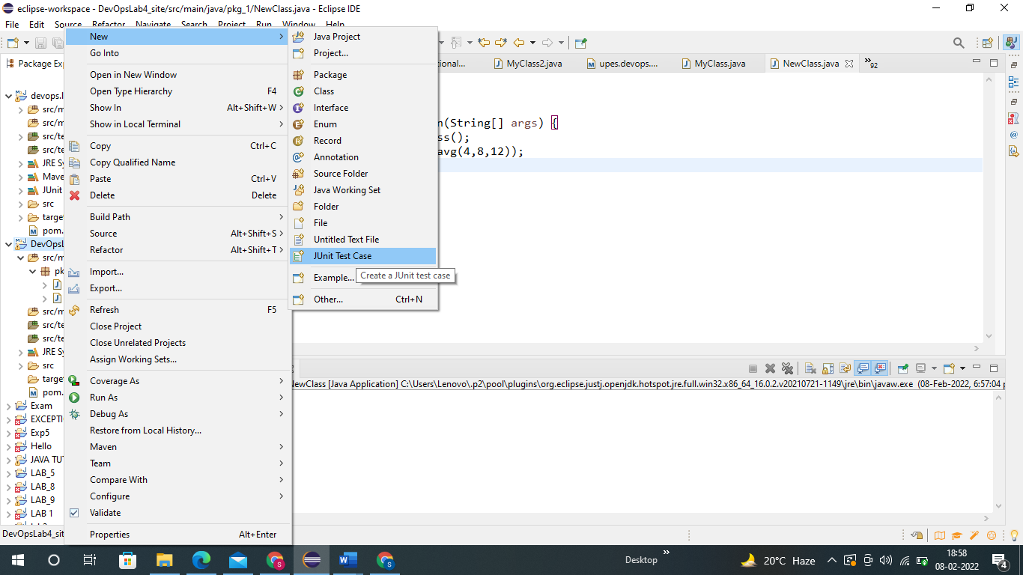

**Step 7:- Now create a test Class and finish.**

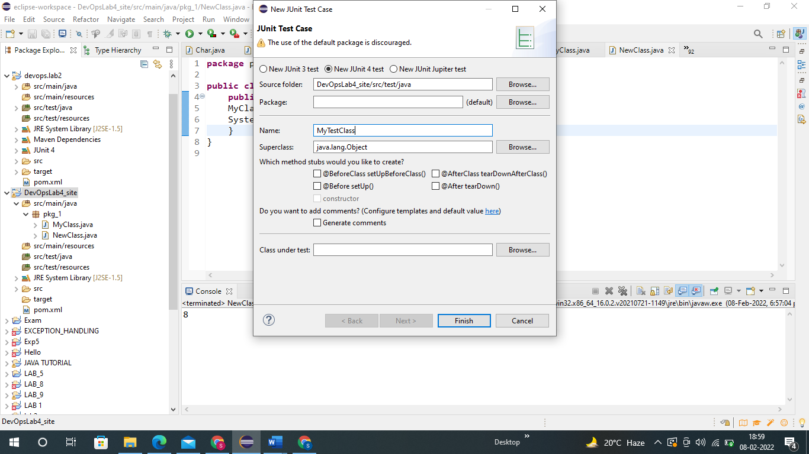

**Step 8 :- Now we can see an already written code. We will cut this fail function and write our**

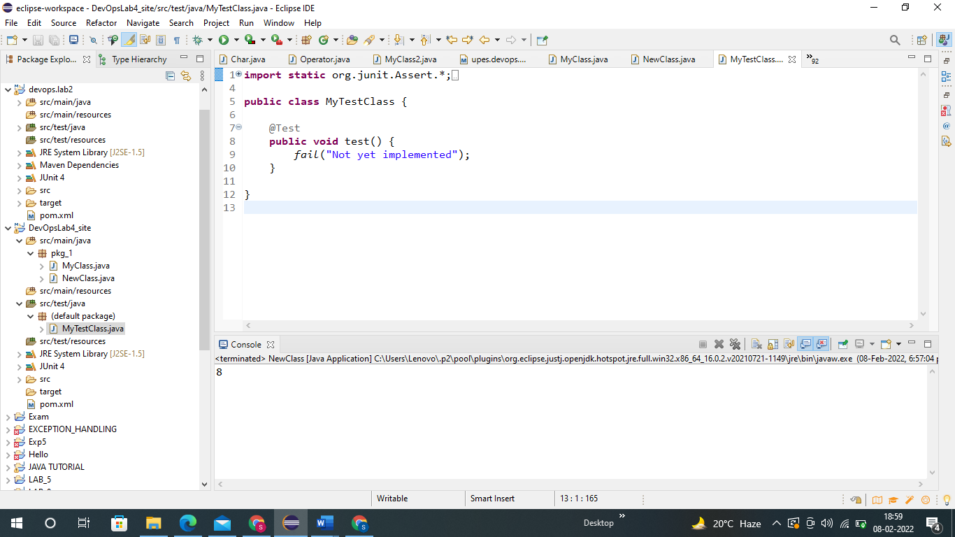

**We will cut this fail function and write our assert Equal function for the testing.**

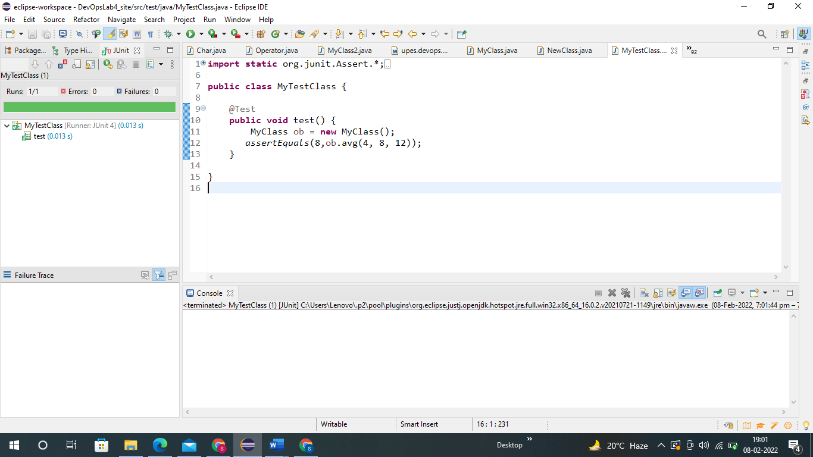

**Step 9 :- Now we will run the Junit test case and we can see that it runs successfully with no Errors and Failure.**



**Step 10 :- Now in our Pom.XML file first we will add this dependency.**

<properties>

<maven.compiler.source>1.8</maven.compiler.source>

<maven.compiler.target>1.8</maven.compiler.target>

</properties>

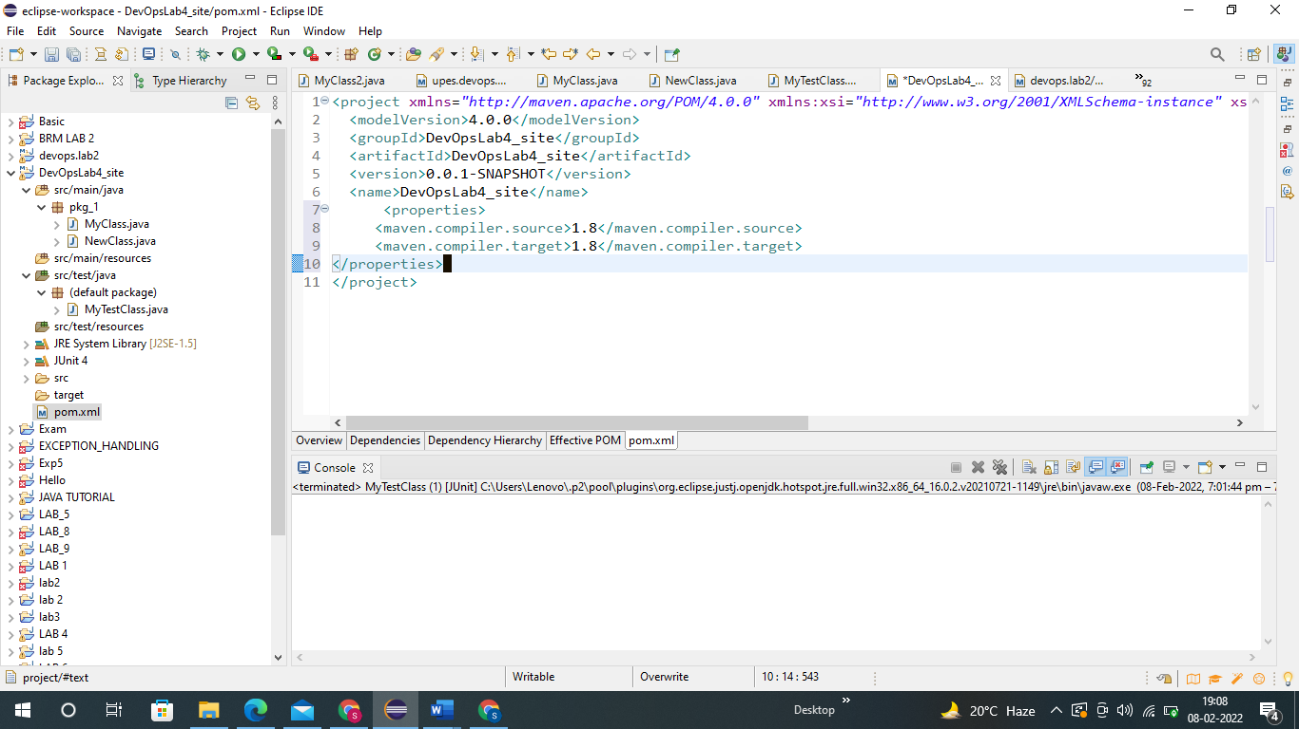

**Step 11 :- Now we will do Maven build and set goal as install.**

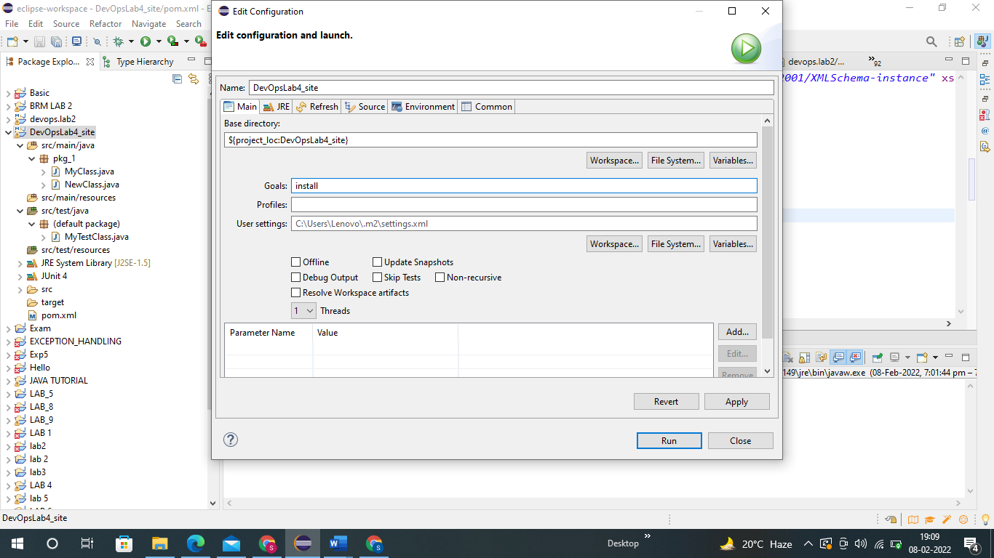

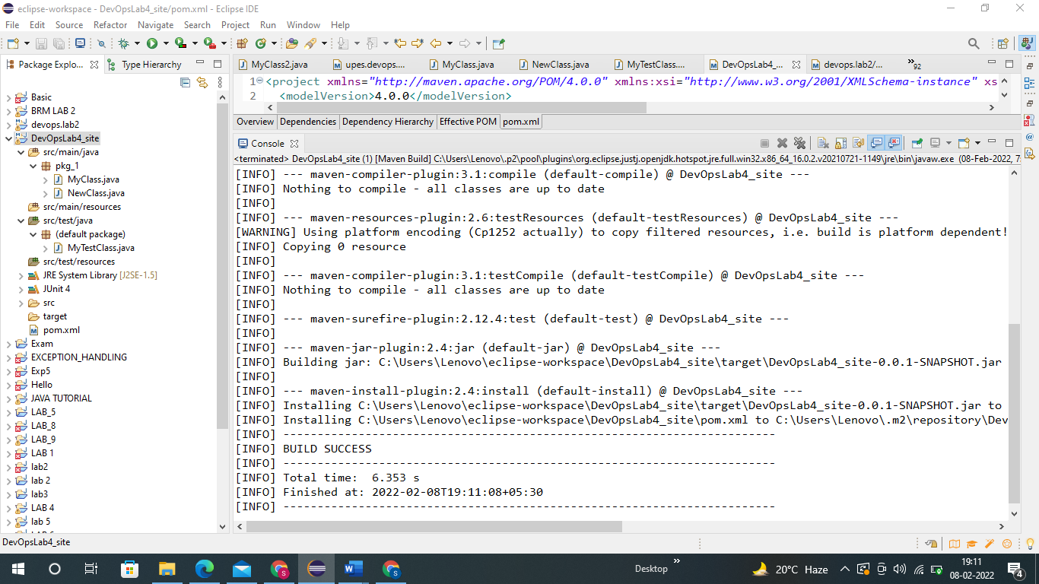

**Step 12 :- Now will add a new dependency in the pom.xml file.**

<dependencies>

<dependency>

<groupId>junit</groupId>

<artifactId>junit</artifactId>

<version>4.12</version>

<scope>test</scope>

</dependency>

</dependencies>

<reporting>

<plugins>

<plugin>

<groupId>org.apache.maven.plugins</groupId>

<artifactId>maven-project-info-reports-plugin</artifactId>

<version>3.0.0</version>

</plugin>

</plugins>

</reporting>

<build>

<plugins>

<plugin>

<groupId>org.apache.maven.plugins</groupId>

<artifactId>maven-site-plugin</artifactId>

<version>3.7.1</version>

</plugin>

</plugins>

</build>

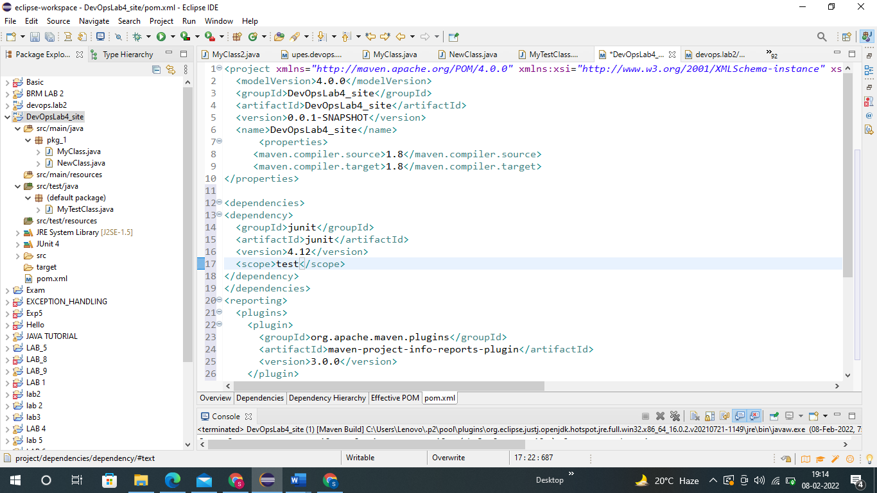

**Step 13 :- Now again do maven build but this time set Goal as site.**

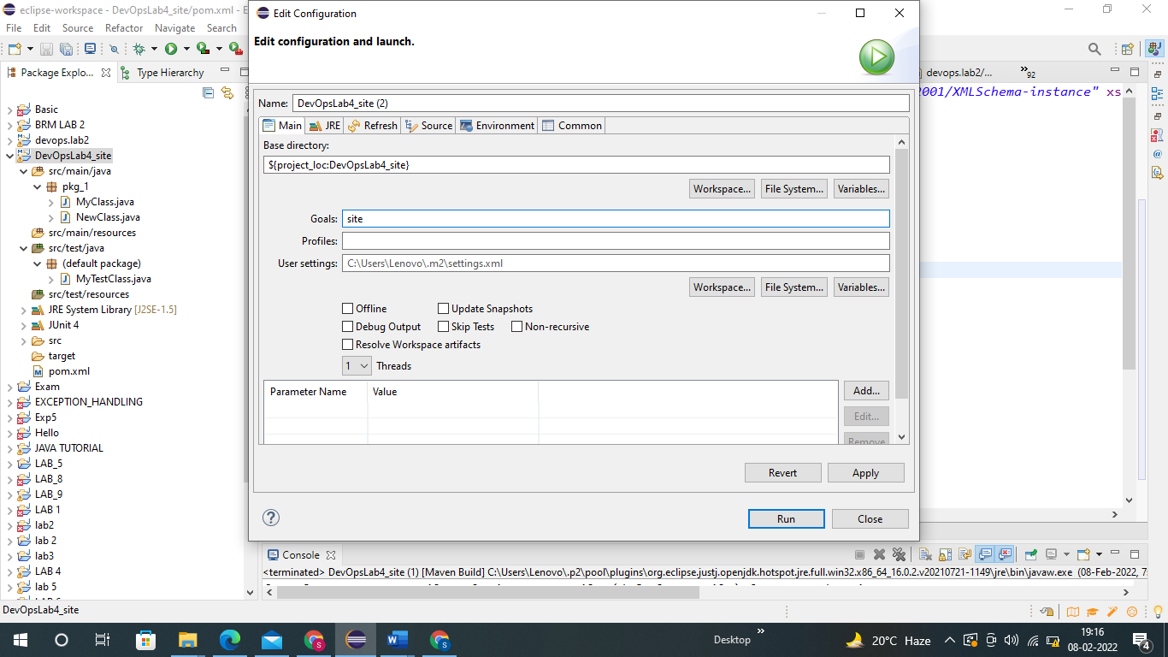

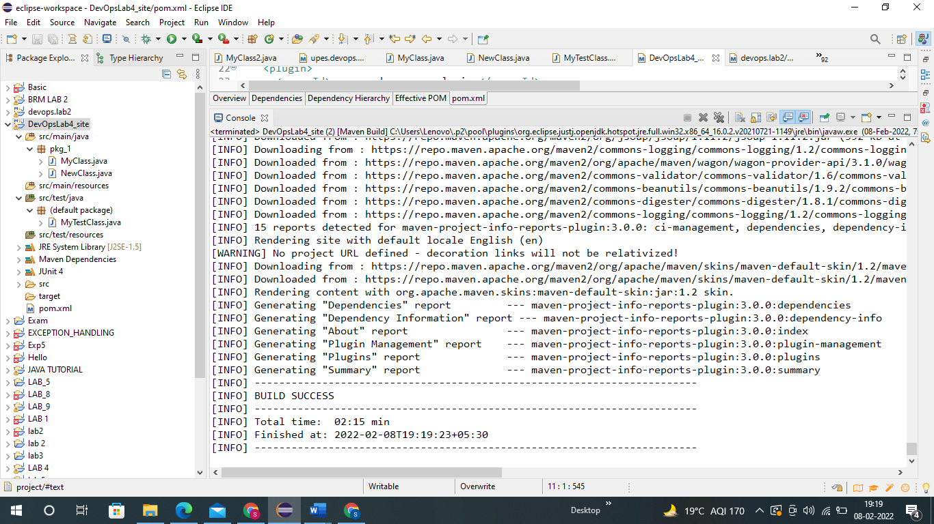

**Now we can see BUILD SUCCESS !!!!**

**Step 14 :- Now Go to the Drive and look for the site folder which is been created.**

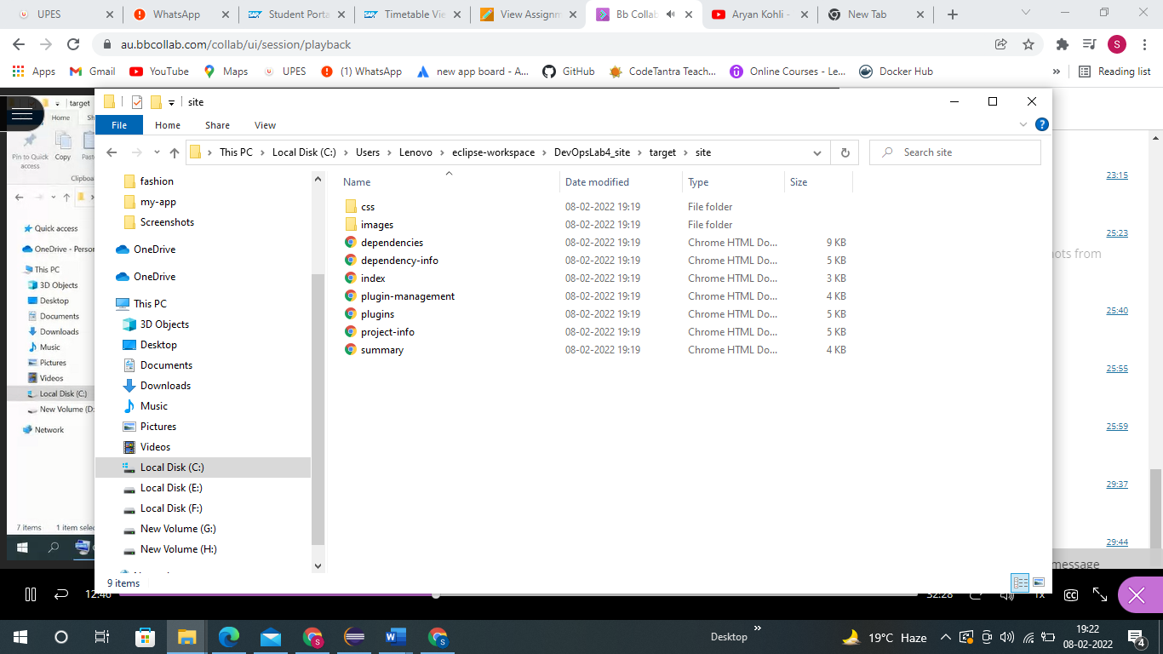

**Here we see that it Automatically downloaded sites for us where we can see different things such as Plugins, Dependency used, index etc.**

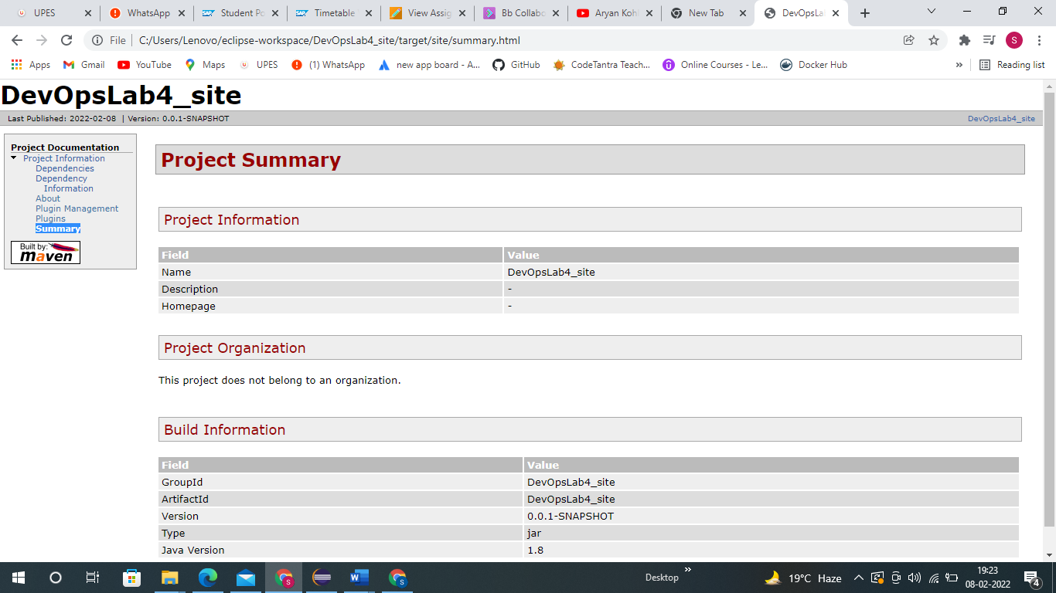

**THANK YOU**